Ross Lewis, Stuart Canning, Jack Patterson, Matthew Spratt

40244063, 40244065, 40267457 , 40240205

CSC2045 – sEMESTER 2 WEEK 11 – THE SYSTEM, FINAL PDF REPORT AND THE PROCESS

# 

# 1.Design Documentation

## Documented Interface Design

**Navigation bar**

This screenshot shows the navigation bar of the festival website. This navigation bar is made available on all the web pages. This interface is designed in a way to allow a user to successfully navigate through the website at ease. From here, the user can navigate to the home page, shows, venue and login page.

**Footer**

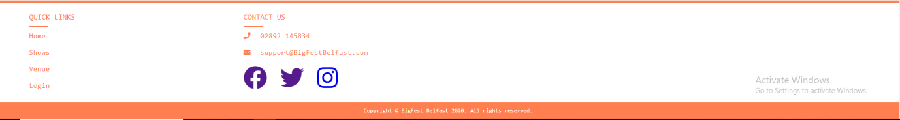

This screenshot shows the footer of the festival website. This footer is also seen across all the web pages. This is designed in a way to allow the user to quickly navigate to different sections of the website and be redirected to external social media platforms which they can use to find out more information on the festival

**Home Page**

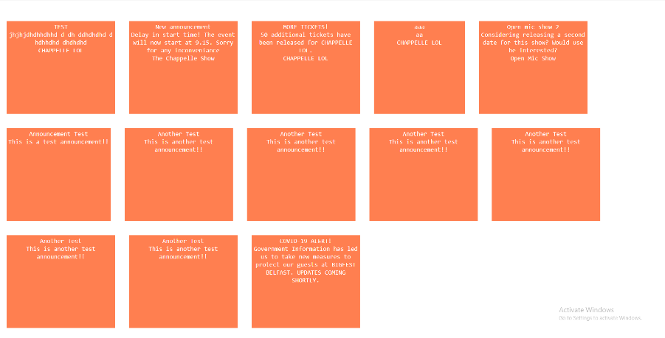

The homepage is the centre of navigation around the website. Any user is able to navigate to the shows, venue or login page. The user is also presented with announcements about shows and venues on this page.

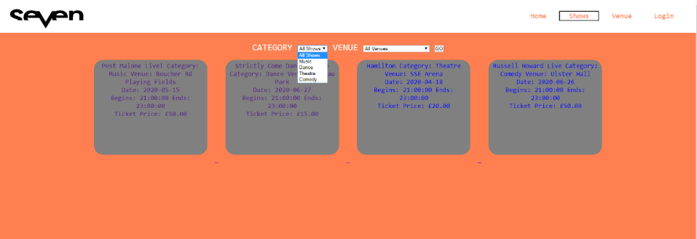**Shows Page**

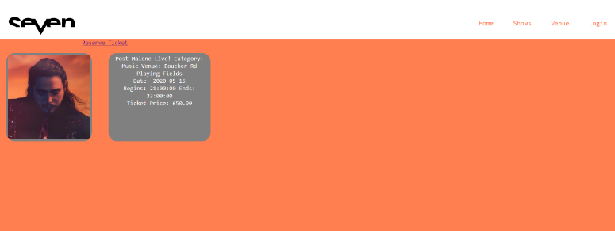The above screenshot is of the shows page on the website. This interface is designed in a way to allow the user to see clearly what shows are on. Drop down menus are available for the user to find a specific type of show or venue. Each of these shows presented can be clicked on where the user is redirected to more information and able to book tickets for that specific show.

This screenshot shows the interface when the user clicks on one of the shows. From here the user can navigate back to the original page or reserve a ticket for this show.

**Venues Page**

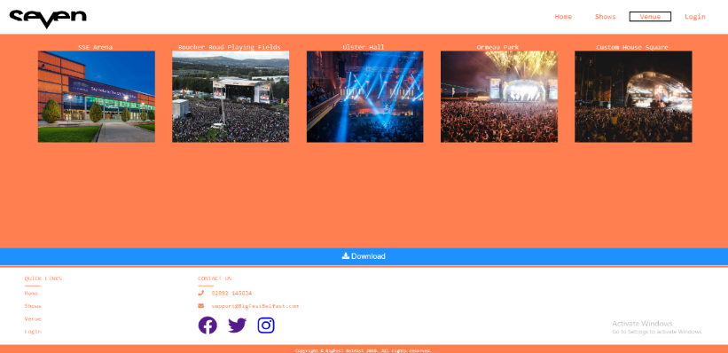This screenshot shows the interface design of the venue page. This is designed in a way to allow the user and performers to see what venues are available.

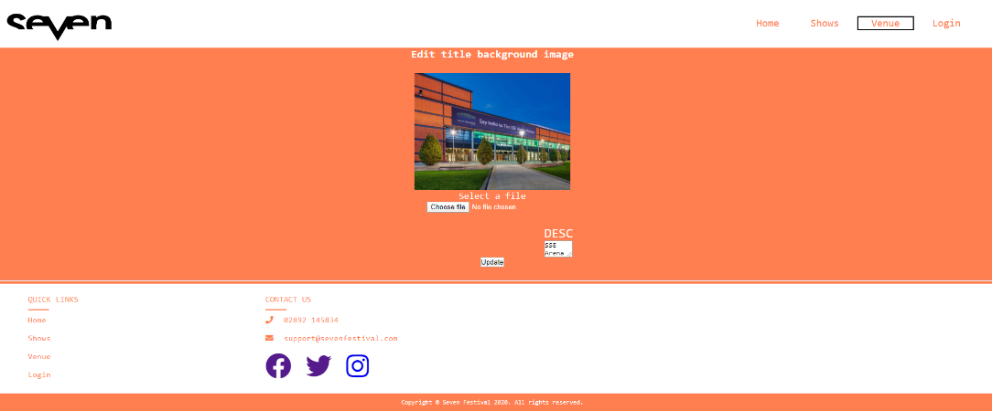

The above screenshot shows the interface design whenever a venue manager is editing a venue. This is designed in a way to be as simple as possible for the user as they can select a new image, give it a new text description and save the changes. This design makes it easy for the user to use the interface.

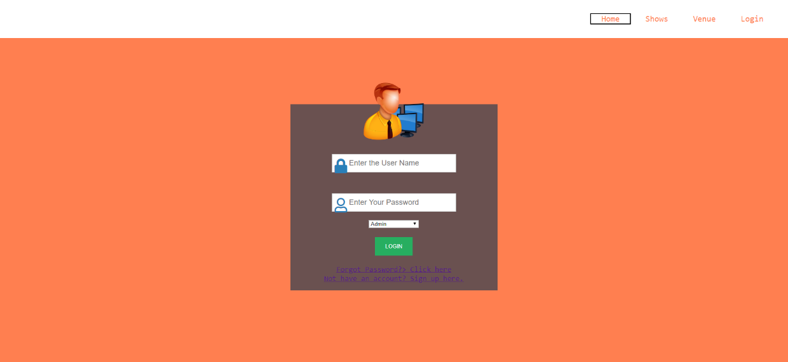**Login Page**

The above screenshot shows the design for the login page interface. This simple design makes it easy for the user to login by entering their username, password and select their user type from the drop-down menu. The user is also able to redirect to the registration page if they don’t have an account through one click. This design also allows the user to easily redirect to a forget password page if they can’t login to their account.

**Registration Page**

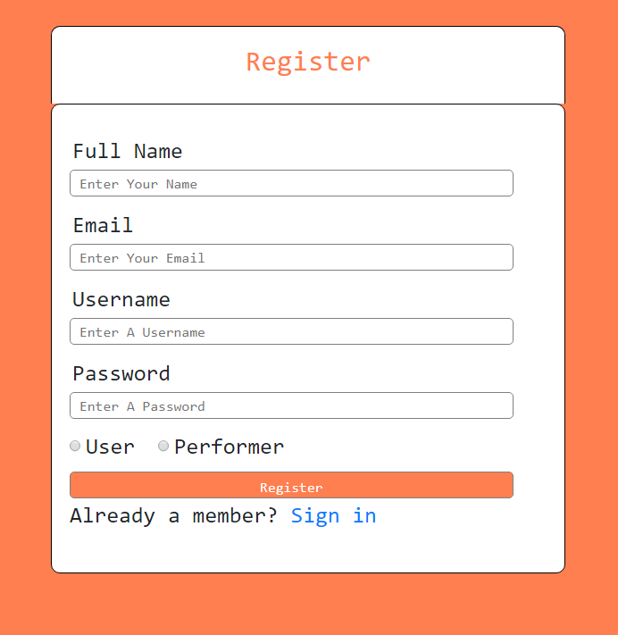

This is a screenshot of the user interface design of the registration page. This makes it as easy as possible for the user to register onto the website by following this form. After inserting all information and clicking register, the user is prompted with a success message where they can then redirect to the login page. This design makes it as easy as possible for a user to register onto the website.

**Forget Password Page**

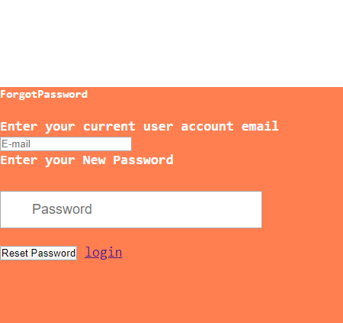The forget password page allows the user to enter the email linked to their account and insert a new password to login with. After doing so, the user can redirect back to the login page and use these new details to access the website.

**Reviews Page**

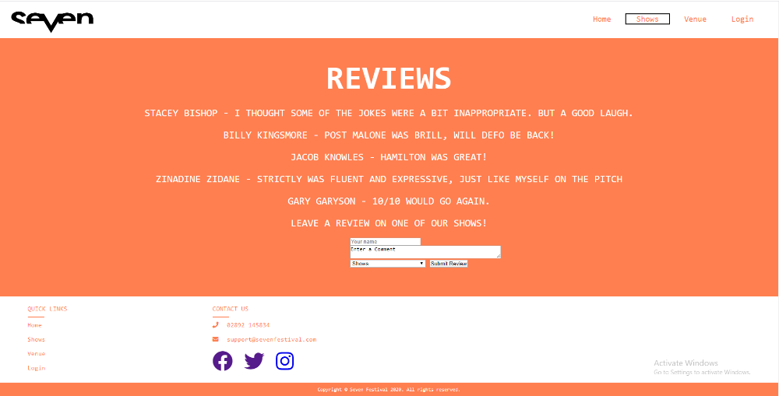The reviews page allows users to leave a review on a specific show whenever they’re logged in. Other users’ reviews can be viewed by all users. The form at the bottom makes it simple for the user to submit their review by inserting their name, comment and selecting which show they attended.

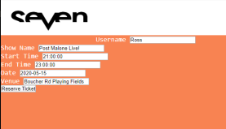**Booking Page**

The booking page makes it very easy for a user to reserve a ticket. After clicking a specific show when logged in, the form autofill’s with the username. This allows a user to easily reserve a ticket for the show which is then stored on the database.

**Admin Panel**

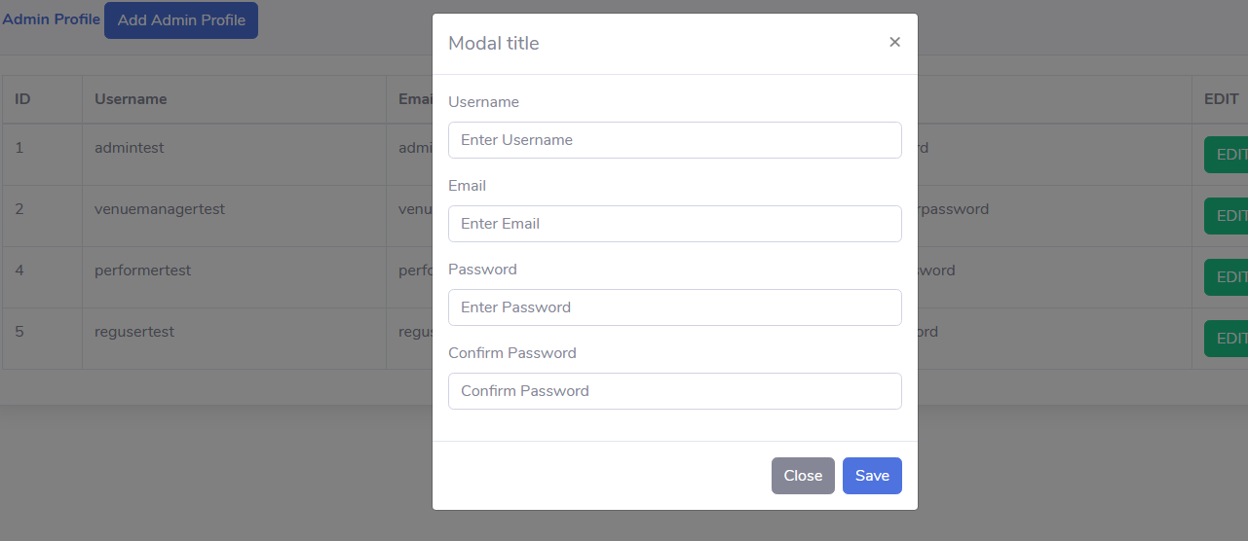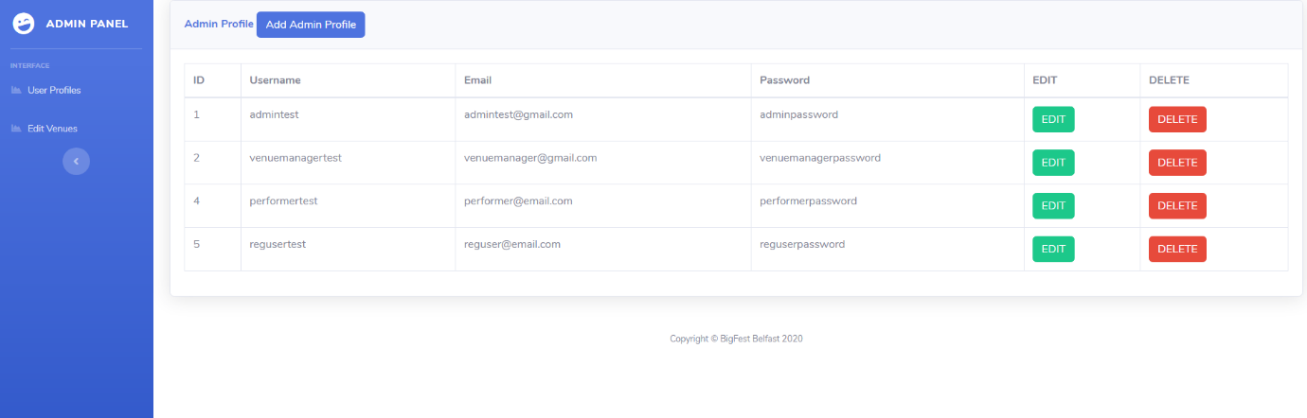This screenshot shows the admin panel. The admin is redirected to this page upon logging in. This interface is designed in a way to make it as easy as possible for the admin to see the high-level user details and edit/delete these users where necessary. The admin is also able to add new profiles through the add profile button located at the top of the admin panel. This simple layout makes it as easy as possible for the admin.

This is the simple interface design of the adding a profile section on the admin panel. This makes it easy for the admin to add a new account by filling out the form.

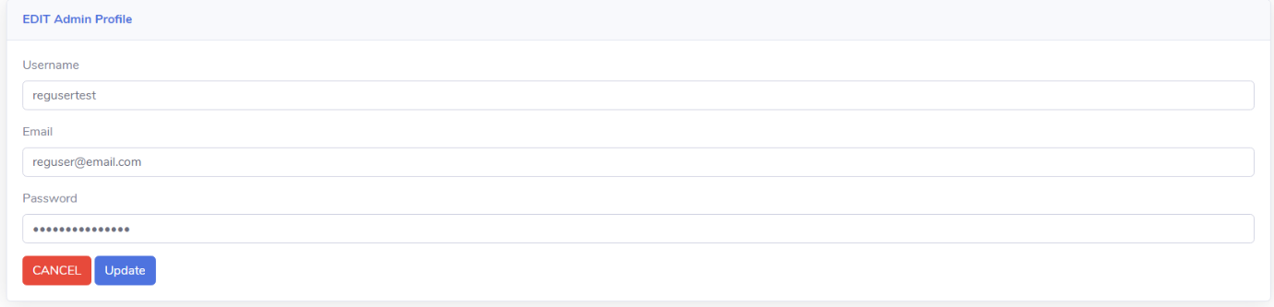This interface is designed to make it as easy as possible for the admin to easily update a profile. From here the admin can change the username, email and enforce password changes. This design makes it easy for the admin to save these changes to the database and update user profiles.

**Venue Manager Profile**

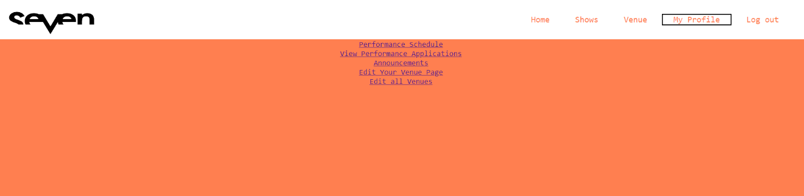The venue manager is designed in a way to allow the venue manager to easily navigate around their venue details by looking at schedules of the venue, applications and the editing of the venue’s details. The href tags make it easy for the venue manager to navigate to these pages. When logged in, the profile of the user that logged in is displayed to the user.

**Venue Manager Edit Venue Page**

The edit venue page allows the user to insert venue details and upload an image and save the changes. This make it very easy for the manager to edit his specific venue details. The venue that is being edited and displayed to the user is one that the venue manager manages.

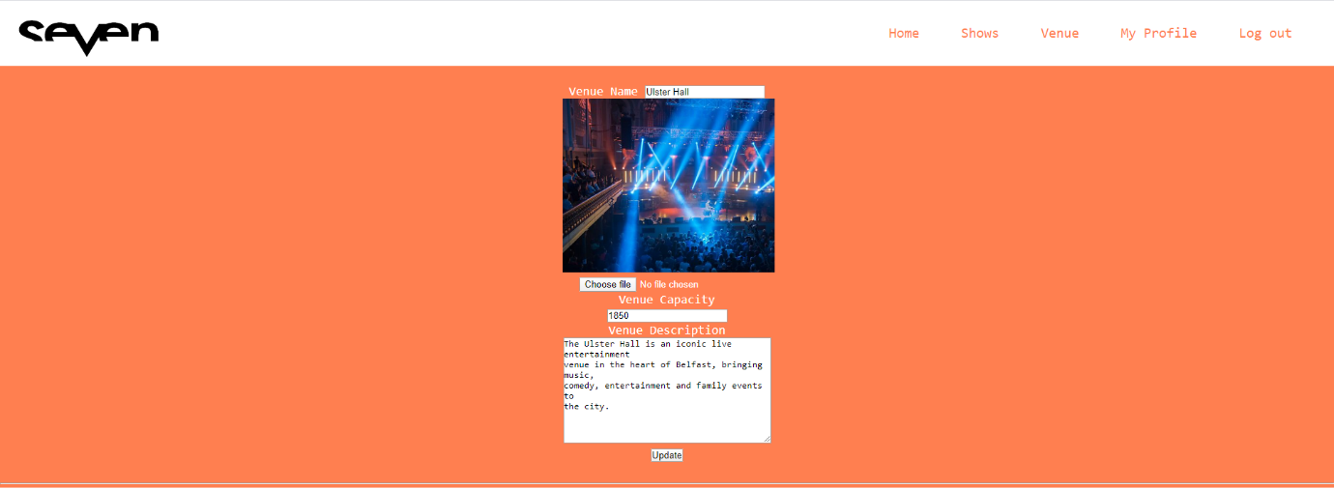**Venue Manager Performance Schedule**

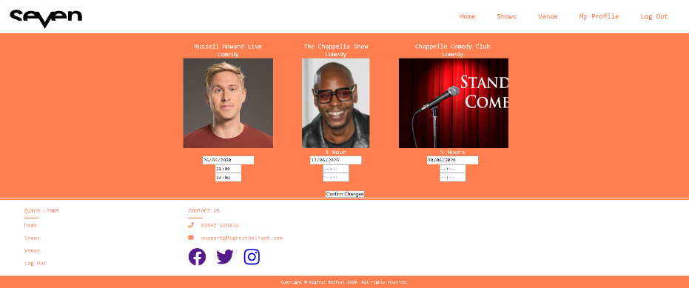

The performance schedule allows the Venue Manager to see when a performer is playing at their venue. From here they can easily adjust the date and time of a specific show.

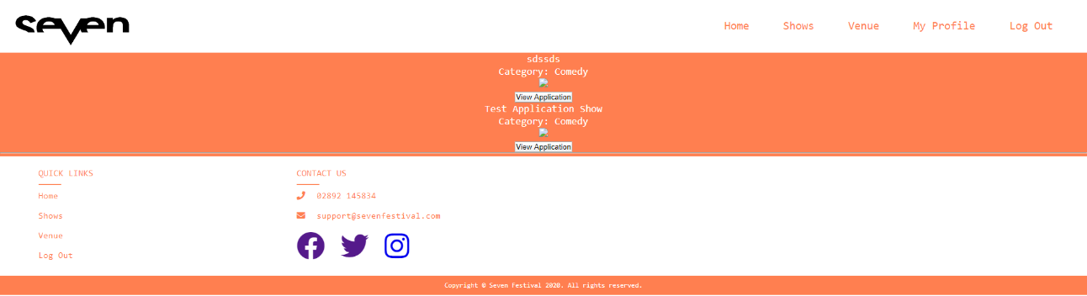

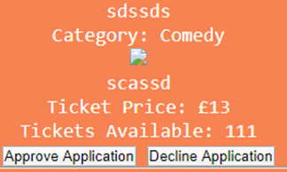The application page allows for a venue manager to see applications for performers to perform at their venue. From here the manager can click into the application, see more details about it and then approve or decline it.

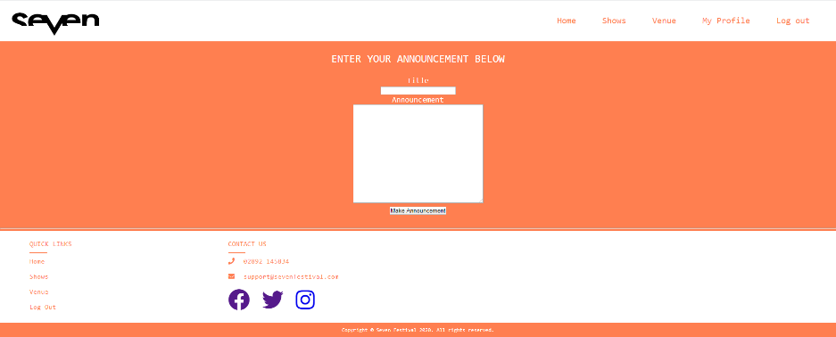

The above image shows the announcements page. The Venue Manager is able to insert a title and text and make the announcement. This is then displayed on the homepage for all users to see. This helps to give information on the managers Venues to all users.

**Performer Venue Application**

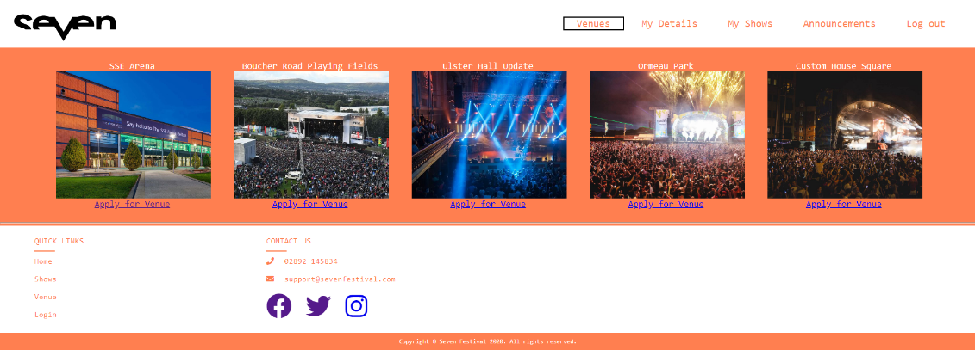After logging in as a perfomer, the venues page allows the user to select a venue that they want to apply to perform at. This is done through a button below each venue which redirects the user to an application form for that specific venue.

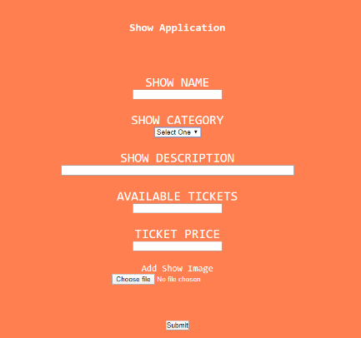

This is the show application that the user must fill out to apply to perform a show at that specific venue. They can select their category from the drop down menu and provide the other details by filling out the form.

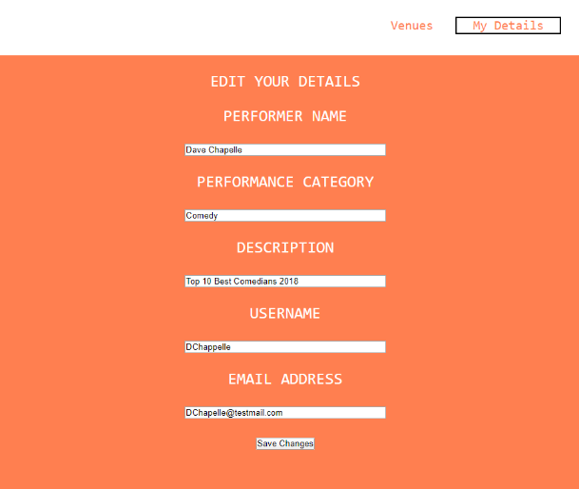

This is the ‘My Details’ page for the performer. This shows the details of the specific performer that has logged in. From here the performer can make any necessary changes required to their details.

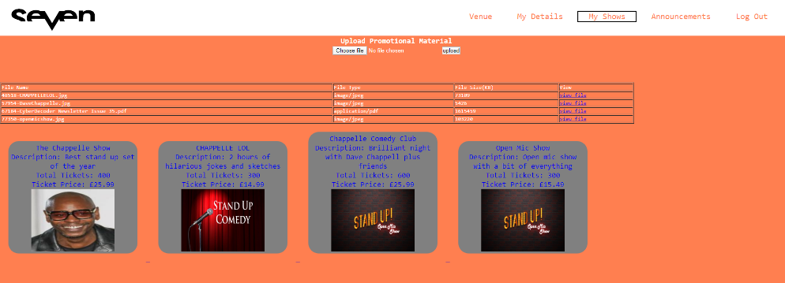

The ‘My shows’ page for the performer shows all the shows that that specific performer has. From here the user can click on the specific show and see information on it such as the ticket price, the amount of available tickets and how many have been reserved.

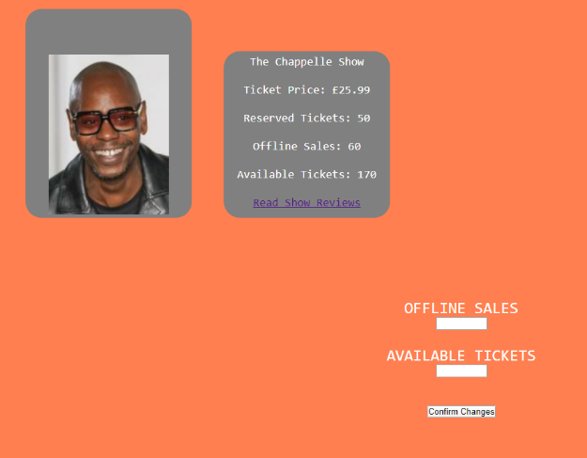This is the design of the specific show. This is where the performer can see how many tickets have been reserved and how many are still available. The performer is also able to go to the reviews section for that specific show and see what reviews users have inputted.

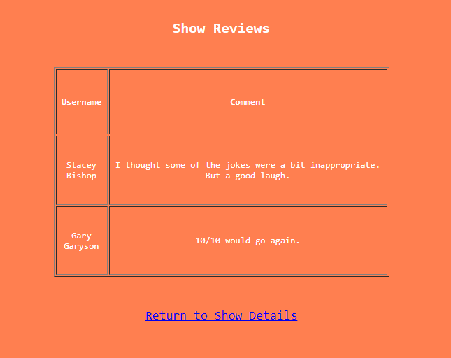

This is the interface design of the shows reviews page. This is designed in a way to make it easy and clear for the user to see the reviews. The shows reviews page allows the performer to see that specific shows reviews.

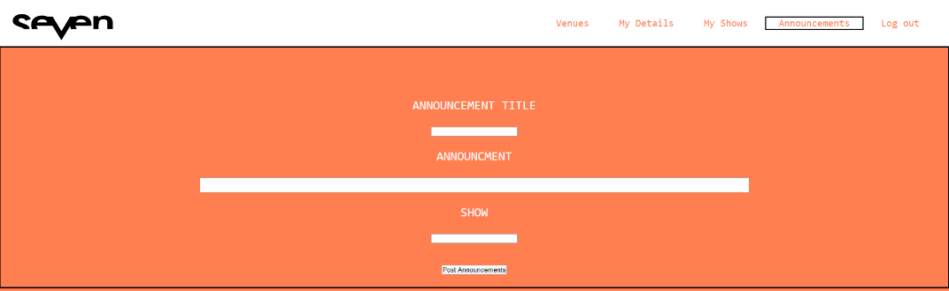

The announcements page has a form which the performer can fill out to give announcements for a specific show that users can view.

## Documented Interface Design

**Sequence Diagram Admin User**

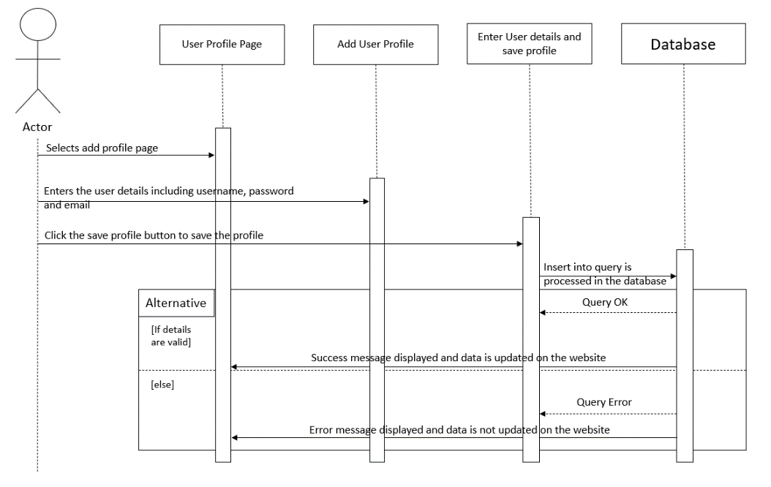

This is admin user for adding user details. The actor must click on the user profile page after logging in. From here the actor selects to add a user profile and inserts the required details of the user. The actor then clicks save and the data is stored on the database.

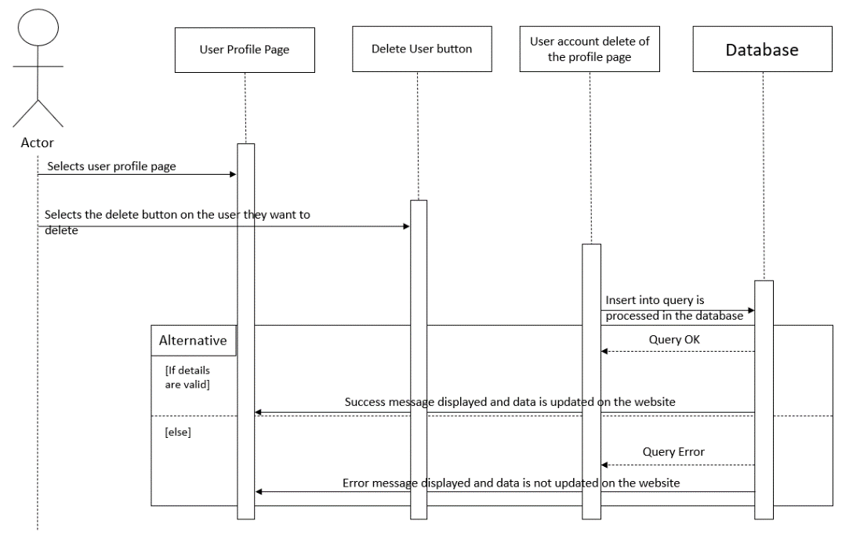

This for the deletion of a user account. The actor clicks onto the user page. From here they can select the profile which they want to delete and click the delete button. This is then erased from the database.

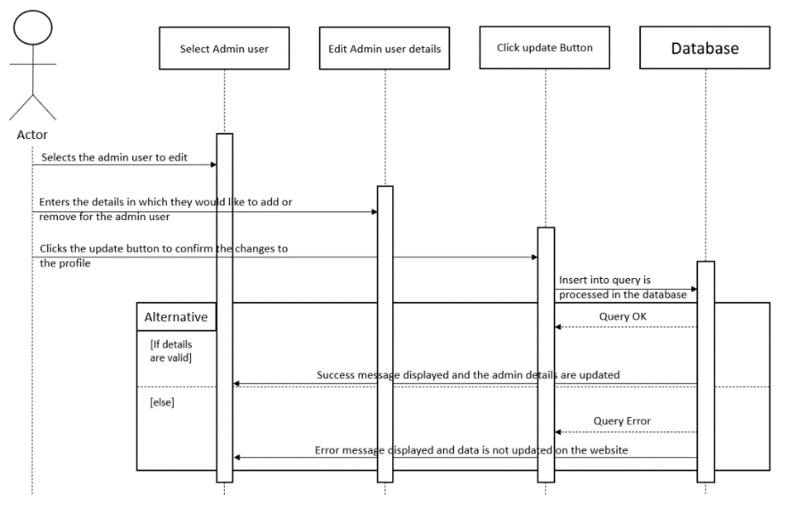

This is for editing account details. The user must click on the user profile page where they select which user profile they want to edit. From here they edit the details and click the save button where they changes are stored onto the database.

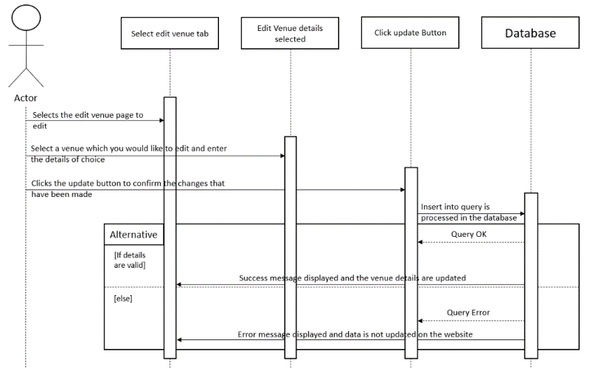

This is the editing venues page. The actor selects the edit venue page. They then select which venue they want to edit and insert the new details/image. The actor clicks the update button where the changes are stored on the database.

# 2. Implementation-Related Documents

**Test Plan**

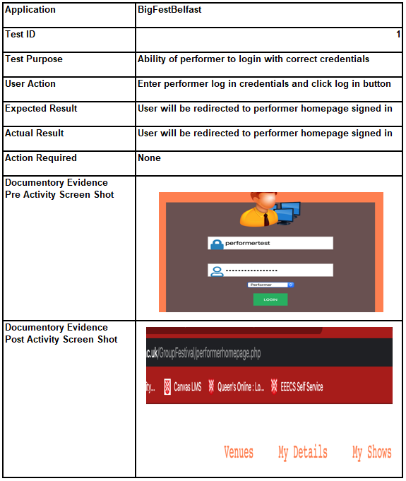

# 

# 

# 

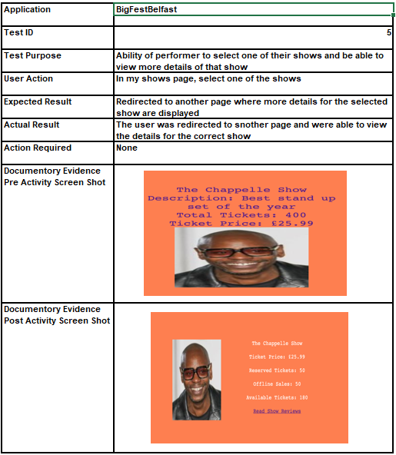

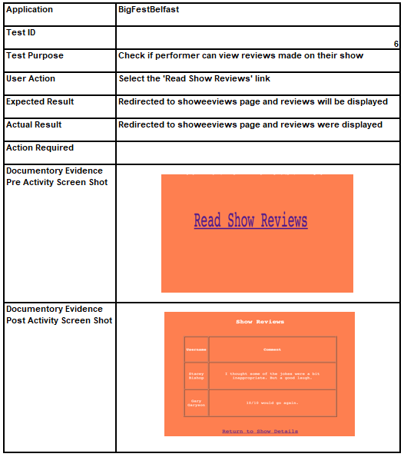

*Further Test Plans are continued within the Appendix at the bottom of the document.*

# 3. Adherence to Process

## Appendix

# Minutes for Team G 7 Week commencing 3/2/20 Date of this minute 3/2/20

The following team members were present

|  |  |
| --- | --- |
| Name (printed/typed) | Signature |
| Jack Patterson | Jack Patterson |
| Matthew Spratt | Matthew Spratt |
| Ross Lewis | Ross Lewis |
| Stuart Canning | Stuart Canning |

Task Reporting (Briefly list the progress for each team member in the last week.*)

Jack Patterson

* Made myself more familiar with the assignment and what we will be required to implement.
* Thought of design ideas for database tables

Matthew Spratt

* Made myself more familiar with the assignment and what we will be required to implement.
* Thought of design ideas for database tables
* Began to plan how the shows page would function
* Researched ideas for filters

Ross Lewis

* Made myself more familiar with the assignment and what we will be required to implement.
* Thought of design ideas for database tables
* Researched other familiar sites for design ideas

Stuart Canning

* Made myself more familiar with the assignment and what we will be required to implement.
* Thought of design ideas for database tables

Actions Planned (Briefly list the actions required of each team member for the next week.)

Jack Patterson

* Contribute to creating tables for database
* Getting set up and familiar with group database

Matthew Spratt

* Contribute to creating tables for database
* Getting set up and familiar with group database

Ross Lewis

* Contribute to creating tables for database
* Getting set up and familiar with group database
* Creating HTML & CSS design of site

Stuart Canning

* Contribute to creating tables for database
* Getting set up and familiar with group database

# Minutes for Team G 7 Week commencing 10/2/20 Date of this minute 12/2/20

The following team members were present

|  |  |
| --- | --- |
| Name (printed/typed) | Signature |
| Jack Patterson | Jack Patterson |
| Matthew Spratt | Matthew Spratt |
| Ross Lewis | Ross Lewis |
| Stuart Canning | Stuart Canning |

Task Reporting (Briefly list the progress for each team member in the last week.*)

Jack Patterson

* Created tables and relationships in group database
* Linked the database to the application created by Ross and tested it was working

Matthew Spratt

* Created tables and relationships in group database
* Made sure the foreign keys were working properly in the database
* Linked the database to the application created by Ross and tested it was working

Ross Lewis

* Created tables and relationships in group database
* Designed and created layout for the website

Stuart Canning

* Created tables and relationships in group database
* Linked the database to the application created by Ross and tested it was working

Actions Planned (Briefly list the actions required of each team member for the next week.)

Jack Patterson

* Create a working secure log in system for the site . This is to allow the different user types to be able to log in and get redirected to their required homepages.

Matthew Spratt

* Begin working on the shows and lineup pages.
* Implement a dropdown filter feature on the shows page
* Create the lineup page

Ross Lewis

* Begin work on a venue edit page. This is to allow the venue manager to be able to login to their account and edit the image and description of their venue and save it onto the database.
* Look at what pages the admin will require on the website

Stuart Canning

* Begin design and possible implementation of a booking form on the webpage which will allow a user to book a ticket for a specific show.
* Complete research into how booking forms are linked and developed.

# Minutes for Team G 7 Week commencing 17/2/20 Date of this minute 17/2/20

The following team members were present

|  |  |
| --- | --- |
| Name (printed/typed) | Signature |
| Jack Patterson | Jack Patterson |
| Matthew Spratt | Matthew Spratt |
| Ross Lewis | Ross Lewis |
| Stuart Canning | Stuart Canning |

Task Reporting (Briefly list the progress for each team member in the last week.*)

Jack Patterson

* Created log in page and uploaded to GitLab so other team members could use it.
* Delegated registered performer user and began to look at possibilities for pages

Matthew Spratt

* Completed the shows and lineup pages
* Created the dropdown filter for shows on the shows page

Ross Lewis

* Completed a venue edit page. This is to allow the venue manager to be able to login to their account and edit the image and description of their venue and save it onto the database.
* Looked at the brief to decide which pages the admin user will require to meet the client’s requirements.

Stuart Canning

* Research was completed on the booking page and a basic booking form was created with weblinks which allow for the user to navigate to the form.

Actions Planned (Briefly list the actions required of each team member for the next week.)

Jack Patterson

* Focusing on development for the working system.
* Complete an edit details page where the performer can change their details and it is updated and saved in the database.

Matthew Spratt

* Link the shows and lineup pages
* Begin planning and working on the venue manager user

Ross Lewis

* Begin working on the admin panel to allow the user to securely login to edit/delete user profiles

Stuart Canning

* Finalise the booking form by linking it to the website database which will all for it to store ticket information as well as the current user logged in.

# Minutes for Team G 7 Week commencing 24/2/20 Date of this minute 27/2/20

The following team members were present

|  |  |
| --- | --- |
| Name (printed/typed) | Signature |
| Jack Patterson | Jack Patterson |
| Matthew Spratt | Matthew Spratt |
| Ross Lewis | Ross Lewis |
| Stuart Canning | Stuart Canning |

Task Reporting (Briefly list the progress for each team member in the last week.*)

Jack Patterson

* Completed edit details page for performers.
* Worked on announcements page that when finished will post announcements that will be viewable by registered members of the public who have reserved tickets to one of the performers shows.

Matthew Spratt

* Planned out the venue manager pages
* Linked the shows page to the lineup page so that when a show is clicked it is displayed on its own on the lineup page along with the performance lineup of the show
* Began working on the venue manager home page

Ross Lewis

* Started working on the admin panel, getting the design set out along with an edit button to edit user details including username, password and email.

Stuart Canning

* Booking form has been completed with user being able to login and book a ticket. The form takes the usernames details and the ticket information and allows for the information to be stored in the database system.

Actions Planned (Briefly list the actions required of each team member for the next week.)

Jack Patterson

* Continuing to focus on development for the working system.
* Enable a performer to be able to apply for a specific venue with one of their shows

Matthew Spratt

* Complete venue manager home page
* Begin working on the edit venue page

Ross Lewis

* Complete the admin panel and requirements by creating a functionality which allows the administrator to delete user accounts
* Create test accounts to test that the edit and delete functionality works.

Stuart Canning

* Begin working towards creating a forget password function for the login page for all users to gain access to.
* Complete some research into different design concepts of user forget password functions.

# Minutes for Team G 7 Week commencing 2/3/20 Date of this minute 3/3/20

The following team members were present

|  |  |
| --- | --- |
| Name (printed/typed) | Signature |
| Jack Patterson | Jack Patterson |
| Matthew Spratt | Matthew Spratt |
| Ross Lewis | Ross Lewis |
| Stuart Canning | Stuart Canning |

Task Reporting (Briefly list the progress for each team member in the last week.*)

Jack Patterson

* Produced code that allowed a performer to apply to a venue and complete a form with details about the show and an image. These details were stored on to the group database in a show applications table.
* Completed announcements page

Matthew Spratt

* Completed the edit venue page and began working on the applications page
* Created more tables in the database to be able to fetch the correct data from it with queries

Ross Lewis

* Fully completed the admin panel by developing a function to allow the admin to delete a user account
* Created test data to test that the edit and deletion of user accounts works.

Stuart Canning

* Forgot password function was completed by developing a link which allows for the user to access the forget password page in which they can enter their account information and allow for their password to be reset in the database system.

Actions Planned (Briefly list the actions required of each team member for the next week.)

Jack Patterson

* Continuing to focus on development for the working system.
* Required to create functionality where a performer can view his own shows, view more details of their shows and be able to edit, view reviews made about the show and upload relative material for the show.
* Worked on some design documentation for pages completed so far

Matthew Spratt

* Complete applications page
* Begin working on the schedule page

Ross Lewis

* Begin working on a registration page to allow for user accounts of all user types to be created and stored onto the database. This will be linked to the login page that Jack developed.
* Begin working on the design documentation for pages completed so far.

Stuart Canning

* Begin working on a review page which can be linked to the shows page which will allow for users to read and write new reviews on different shows which will be saved into the database.

# Minutes for Team G 7 Week commencing 9/3/20 Date of this minute 9/3/20

The following team members were present

|  |  |
| --- | --- |
| Name (printed/typed) | Signature |
| Jack Patterson | Jack Patterson |
| Matthew Spratt | Matthew Spratt |
| Ross Lewis | Ross Lewis |
| Stuart Canning | Stuart Canning |

Task Reporting (Briefly list the progress for each team member in the last week.*)

Jack Patterson

* Completed final pieces of required functionality for the performer in the working system. A performer can now view more details of their shows and meet the requirement of changing ticket sizes downwards. They can view reviews made on their shows and upload files relevant to their shows.

Matthew Spratt

* Completed the applications and edit schedule pages
* Began working on the announcements page

Ross Lewis

* Fully completed the registration page to allow users to create accounts of all user types. The user can now register and use these details to login securely.
* Began working on the design documentation.
* Created test accounts through the registration to ensure that registration works.

Stuart Canning

* Completed a working review page which can be accessed from the shows page on the website. The reviews page allows for users to enter a review using a form and select a show using a drop-down menu. This information can then be saved into the database and presented on the reviews page for users to see.

Actions Planned (Briefly list the actions required of each team member for the next week.)

Jack Patterson

* Work with team to produce the final working system.
* Add users and more test data into the site
* Test functionality of pages I produced

Matthew Spratt

* Complete the announcements page
* Work with team to produce the final working system
* Test the system and ensure the functionality is working as it should be

Ross Lewis

* Work with team to produce the final working system.
* Test functionality of pages I produced

Stuart Canning

* Work with the team to produce the final working system.
* Finalise some css on reviews page to make it more presentable.
* Being testing on the pages and functions that I have created.

# Minutes for Team G 7 Week commencing 23/3/20 Date of this minute 23/3/20

The following team members were present

**As we were unable to meet in person, we completed this weeks minutes through Microsoft teams.**

|  |  |
| --- | --- |
| Name (printed/typed) | Signature |
| Jack Patterson | Jack Patterson |
| Matthew Spratt | Matthew Spratt |
| Ross Lewis | Ross Lewis |
| Stuart Canning | Stuart Canning |

Task Reporting (Briefly list the progress for each team member in the last week.*)

Jack Patterson

* The requirements for this week is to complete the design documentation for the final report in the form of class relationship models and sequence diagrams to represent the most significant features of the system. I was working alongside Matthew revising our previous model and diagram and making improvements.

Matthew Spratt

* Completed the final parts of my system and put it together with my group
* Tested my final pages to ensure everything was working
* Completed the documentation required for submission

Ross Lewis

* The requirements for this week which I completed was to complete the design documentation of all functionality developed on the website.
* Completed some final testing to ensure that all functionality was working as it should.
* Worked alongside Stuart to ensure that we had most of the system requirements completed.

Stuart Canning

* Managed to complete the requirements I set for myself by completing some more css on the pages that I have developed especially the reviews page to make it more presentable. I also completed some testing on the pages and functions I created to ensure they work correctly. Worked alongside Ross to ensure that we had most of the requirements for the system completed.

Actions Planned (Briefly list the actions required of each team member for the next week.)

Jack Patterson

* By next week we want to have the complete working system after it has been fully tested and any required changes were made.
* Completion of implementation-related documentation
* Producing our final PDF report.

Matthew Spratt

* Put together the final project and documentation with my group
* Make any necessary changes and ensure everything is completed

Ross Lewis

* Collaborate with the rest of the group to put the entire project together using GitHub.
* Make any necessary changes to the documentation.

Stuart Canning

* Collaborate with the rest of the group to put the entire project together using GitHub
* Make any necessary changes to the documentation
* Finalise the test plan once all tests have been completed.

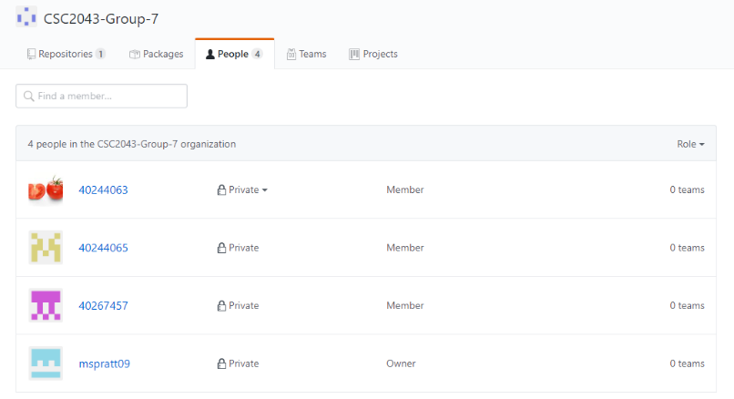**GitHub Organisation**

**Version Managed Code**

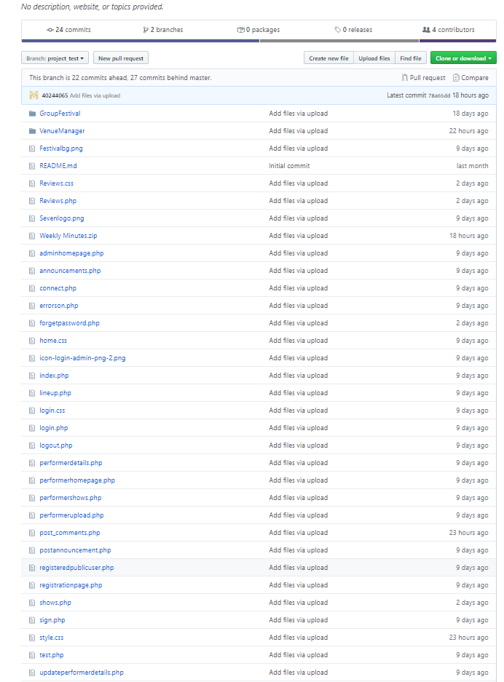

**Remaining Test Plans**

